**B.M.S. COLLEGE OF ENGINEERING BENGALURU**

Autonomous Institute, Affiliated to VTU

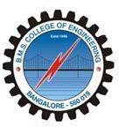

Lab Record

**Artificial Intelligence**

*Submitted in partial fulfillment for the 5th Semester Laboratory*

Bachelor of Technology in

Computer Science and Engineering

*Submitted by:*

**Manasa Sriramaiah**

1BM21CS101

Department of Computer Science and Engineering

B.M.S. College of Engineering

Bull Temple Road, Basavanagudi, Bangalore 560 019 Nov-Mar 2024

B.M.S. COLLEGE OF ENGINEERING DEPARTMENT OF COMPUTER SCIENCE AND

ENGINEERING

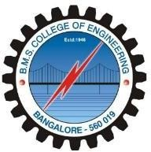

***CERTIFICATE***

This is to certify that the Artificial Intelligence (22CS5PCAIN) laboratory has been carried out by Manasa sriramaiah (1BM21CS101) during the 5th Semester Nov-March- 2024.

Signature of the Faculty Incharge:

Prof. Sneha S Assistant Professor

Department of Computer Science and Engineering

B.M.S. College of Engineering, Bangalore

**Table of Contents**

|  |  |
| --- | --- |
| **Sl. No.** | **Title** |
| 1. | Tic Tac Toe |
| 2. | 8 Puzzle Breadth First Search Algorithm |
| 3. | 8 Puzzle Iterative Deepening Search Algorithm |
| 4. | 8 Puzzle A* Search Algorithm |
| 5. | Vacuum Cleaner |
| 6. | Knowledge Base Entailment |
| 7. | Knowledge Base Resolution |
| 8. | Unification |
| 9. | FOL to CNF |
| 10. | Forward reasoning |





